**1.To print a array as a zig-zag pattern.**

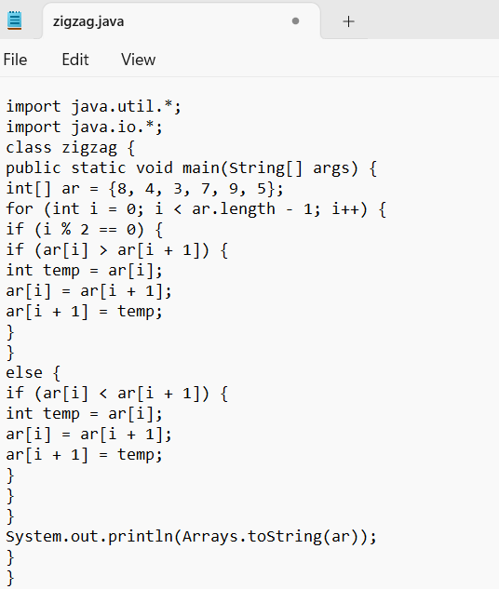

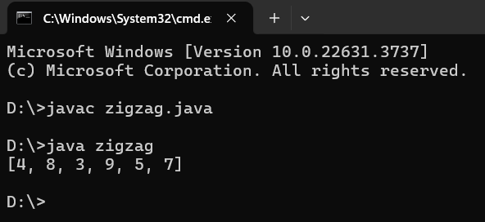

**2. Write a java code to find the peak element in a given array of integers.**

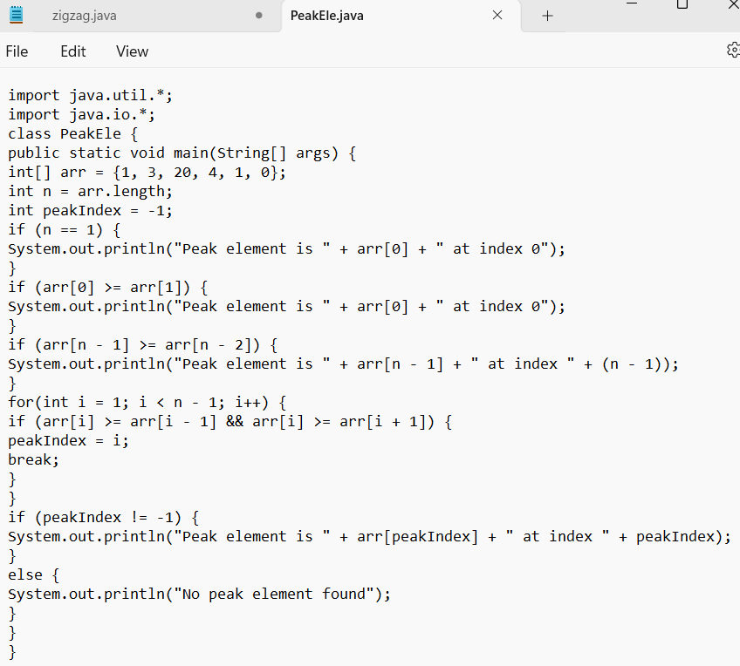

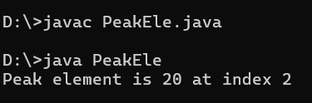

**3. Find the contiguous sub-array with an array(containing atleast 1 number) which has the largest sum.**

I/p: {-2,1,-3,4,-1,2,1,-5,4} O/p=6

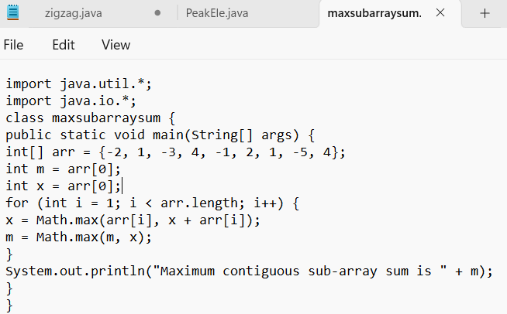

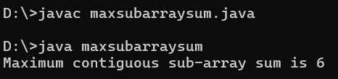

**4. Given a string s consisting of words and spaces, return the length of the last word in the string. A word is a maximal substring consisting of non-space characters only. There will be at least one word, consists of only English letters and spaces ' '.**

Example 1: Input: s = "Hello World" Output: 5

Explanation: The last word is "World" with length 5.

